DevelopAWebApplicationUsingNode-RED

|  |  |
| --- | --- |
| Date | 08-11-2022 |
| Team ID | PNT2022TMID15125 |
| ProjectName | Project-IoTBasedSafetyGadgetForChild  SafetyMonitoring& Notification |
| MaximumMarks | 2 Marks |

StepsFollowed:

* 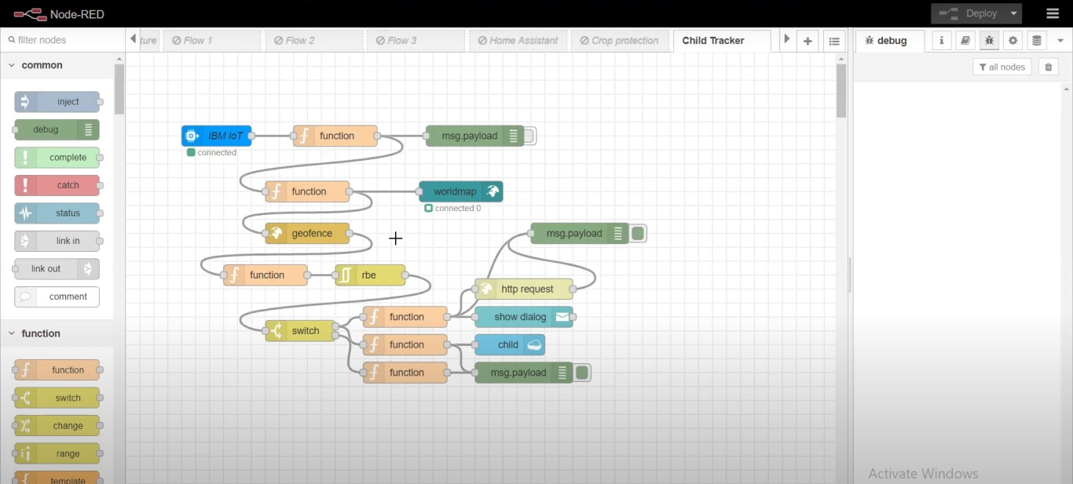OpenedaNode-REDproject
* Addedcodetogetchildlocationinpython

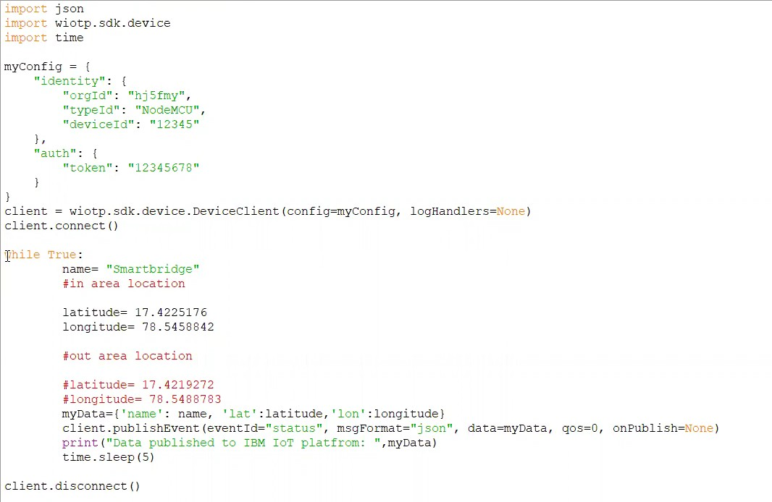

* 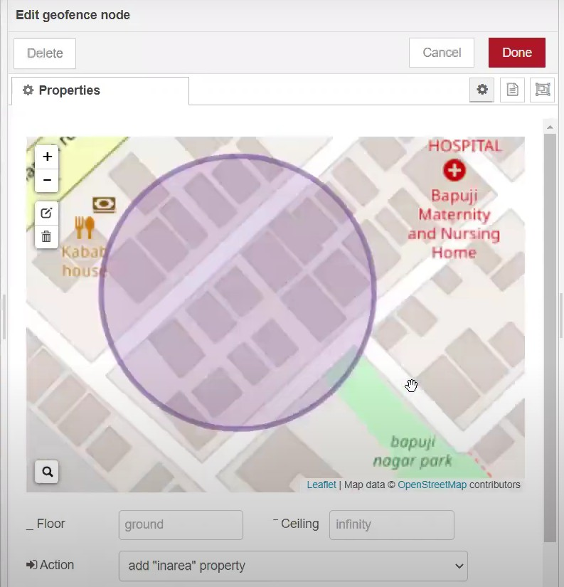CreatedtheGeoFence
* 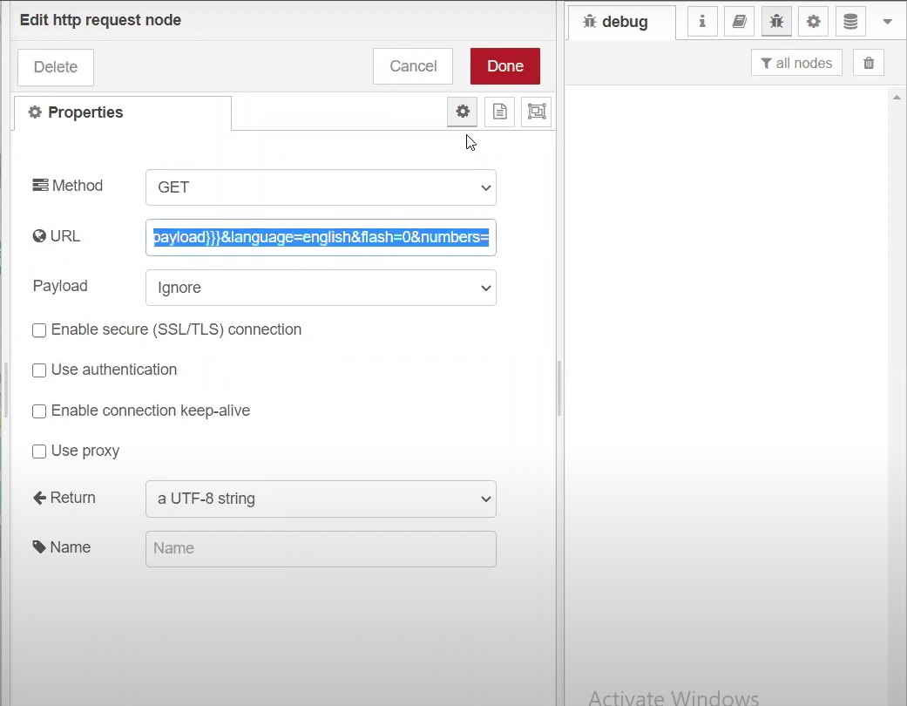EditingtheHTTPRequestURL
* Locatedthechild

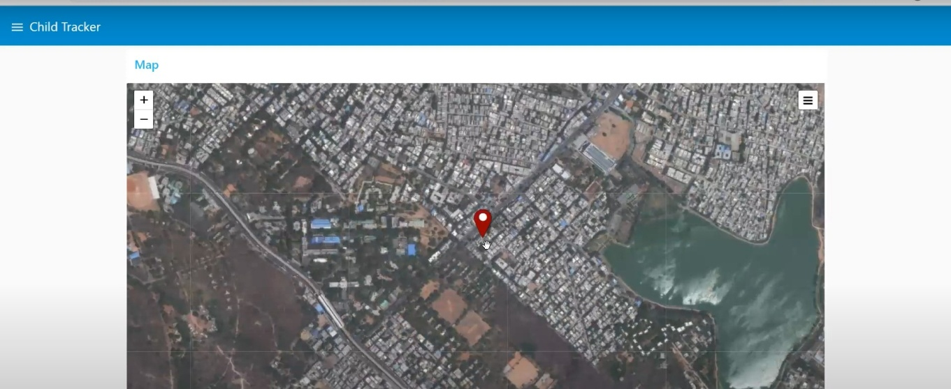

* 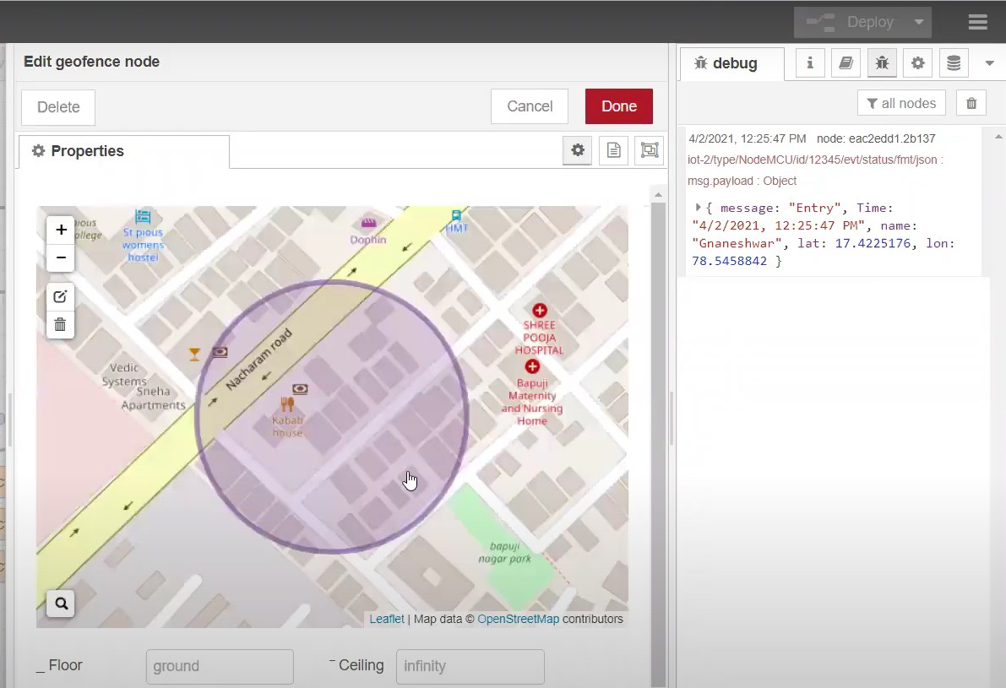Createdthegeofencenode
* PythonscriptsendingrequeststoIBMCloud

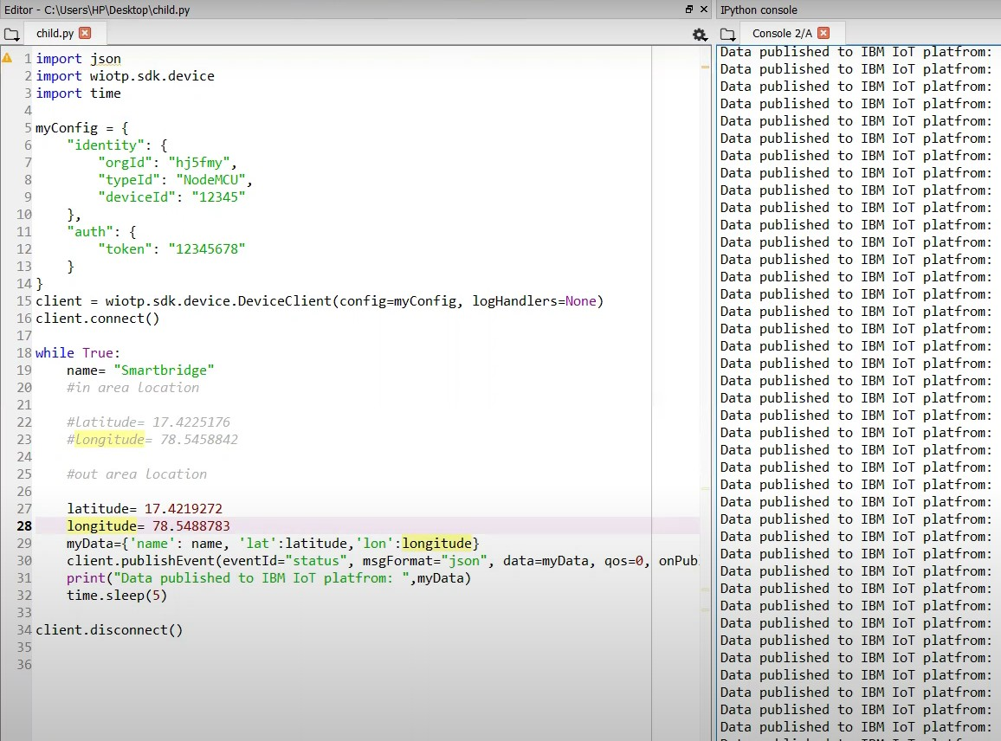

* 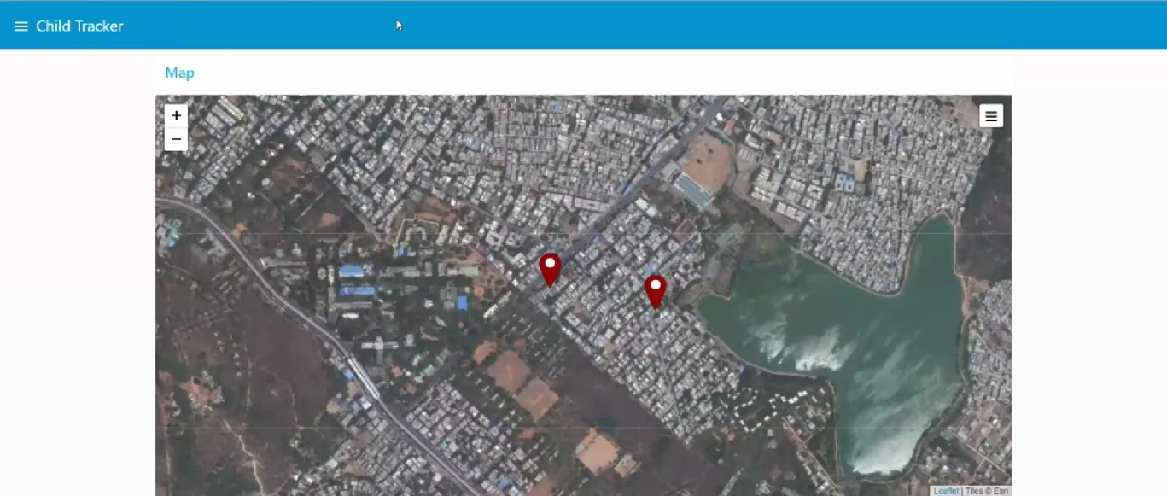Afterrunningthescript,thewebUIshows“Personisnotintheparticulararea”

Result:SuccessfullydevelopedawebapplicationusingNode-RED